Communication Management Plan
DOST STARBOOKS: Whiz Challenge

DOST Science and Technology Information Institute
Gen. Santos Ave., Upper Bicutan,
Taguig City, Metro Manila, 1631, Philippines

APRIL 2026
Table of Contents
Introduction 3
Communications Management Approach 3
Communications Management Constraints 4
Stakeholder Communication Requirements 5
Roles 6
Project Team Directory 7
Communication Methods and Technologies 8
Communications Matrix 10
Communication Flowchart 11
Guidelines for Meetings 11
Communication Standards 13
Communication Escalation Process 14
Glossary of Communication Terminology 15

Introduction
This Communications Management Plan sets out the communications framework for the DOST STARBOOKS Whiz Challenge. It will serve as a guide for communications throughout the life of the project and will be updated as communication needs change. This plan identifies and defines the roles of people involved in this project. It also includes a communications matrix which maps the communication requirements of this project. An in-depth guide for conducting meetings details both the communications rules and how the meetings will be conducted, ensuring successful meetings. A project team directory is included to provide contact information for all stakeholders directly involved in the project.

Communications Management Approach
The Project Manager will take a proactive role in ensuring effective communications on this project. The communications requirements are documented in the Communications Matrix presented in this document. The Communications Matrix will be used as the guide for what information to communicate, who is to communicate, when to communicate it, and to whom to communicate.

As the project progresses, updates or changes to the communication plan may be required due to changes in personnel, scope, or stakeholder needs. The Project Manager is responsible for managing all proposed and approved changes to the communications management plan. Once changes are approved, updates will be distributed to all stakeholders.

This methodology aligns with the project’s change management approach and ensures that all stakeholders, including representatives from the Department of Science and Technology – Science and Technology Information Institute (DOST-STII), remain informed throughout the project lifecycle.

Communications Management Constraints
All project communication activities will occur within the approved budget, schedule, and resource allocations. The Project Manager is responsible for ensuring that communication activities do not exceed allocated resources.

Communication activities will follow the frequencies defined in the Communication Matrix. Any deviation must be approved by DOST-STII.

Organizational policies require that standardized templates and formats be used for all formal communications. Additionally, only authorized personnel from DOST-STII may approve the release of sensitive or confidential information. The Project Manager must ensure proper authorization is obtained prior to distribution.

Stakeholder Communication Requirements
The project includes a diverse group of stakeholders such as DOST-STII representatives, school administrators, educators, students, and the project team. The Project Manager will coordinate with stakeholders to determine their preferred communication methods and frequency.

Stakeholder communication preferences will be documented and maintained in the Stakeholder Register. Standard communication will follow the Communication Matrix, but additional communication may be conducted as needed.

All stakeholders will be provided access to communication platforms used in the project. Secure communication channels will be used when necessary to ensure data confidentiality.

Roles

Project Sponsor
The Project Sponsor is the Department of Science and Technology – Science and Technology Information Institute (DOST-STII). The Project Sponsor is the champion of the project and has authorized it through approval of the project charter. This role is responsible for funding the project and is ultimately accountable for its success. Communications with the Project Sponsor will be presented in summary format unless more detailed information is requested.

Key Stakeholders
Key Stakeholders include DOST-STII representatives, STARBOOKS administrators, school administrators, and educators who have a direct interest in the project. These stakeholders may influence project decisions and are actively involved in providing feedback, reviewing deliverables, and ensuring successful implementation. Regular communication and engagement are required to manage expectations and ensure alignment.

Customer
The customer for this project is Department of Science and Technology – Science and Technology Information Institute (DOST-STII). As the customer who will be accepting the final deliverable of this project they will be informed of the project status including potential impacts to the schedule for the final deliverable or the product itself.

Project Manager
The Project Manager has overall responsibility for the execution of the project. The Project Manager manages day to day resources, provides project guidance and monitors and reports on the projects metrics as defined in the Project Management Plan. As the person responsible for the execution of the project, the Project Manager is the primary communicator for the project distributing information according to this Communications Management Plan.

Project Team
The Project Team is comprised of all persons who have a role performing work on the project. The project team needs to have a clear understanding of the work to be completed and the framework in which the project is to be executed. Since the Project Team is responsible for completing the work for the project they played a key role in creating the Project Plan including defining its schedule and work packages. The Project Team requires a detailed level of communications which is achieved through day to day interactions with the Project Manager and other team members along with weekly team meetings.

Project Team Directory
The following table presents contact information for all persons identified in this communications management plan. The email addresses and phone numbers in this table will be used to communicate with these people.

Role | Name | Title | Organization/ Department | Email
Project Sponsor | Marievic V. Narquita | Head of DOST-STII | Information Services Section (ISS) | mavie.narquita@stii.dost.gov.ph
Project Manager | Kelly Dumbrique | Project Manager | NEXUS | ksdumbrique2@student.apc.edu.ph
Backend Developer | Arcielle Marie Gercan | Backend Developer | NEXUS | acgercan@student.apc.edu.ph
Frontend Developers | Shandrae Lois Quianzon  Kelly Dumbrique  Janice Maxene Salipande | Frontend Developer | NEXUS | saquianzon@student.apc.edu.ph  ksdumbrique2@student.apc.edu.ph  jdsalipande2@student.apc.edu.ph
UI/UX Designers/Illustrators | Shandrae Lois Quianzon  Arcielle Marie Gercan  Janice Maxene Salipande | UI/UX Designers/Illustrators | NEXUS | saquianzon@student.apc.edu.ph  acgercan@student.apc.edu.ph  jdsalipande2@student.apc.edu.ph
QA Lead | Janice Maxene Salipande | QA Lead | NEXUS | jdsalipande2@student.apc.edu.ph
Documentation Lead | Janice Maxene Salipande | Documentation Lead | NEXUS | jdsalipande2@student.apc.edu.ph
Key Stakeholders | See Stakeholder Register | Various Roles | Schools / Educators / Admins | See Stakeholder Register
Customer | DOST-STII | Management | Department of Science and Technology – Science and Technology Information Institute (DOST-STII) | dost@dost.gov.ph

Communication Methods and Technologies
The project team will determine, in accordance with Department of Science and Technology – Science and Technology Information Institute (DOST-STII) organizational policy, the communication methods and technologies based on several factors to include: stakeholder communication requirements, available technologies (internal and external), and organizational policies and standards.

DOST-STII maintains a platform within the PMO which all projects use to provide updates, archive various reports, and conduct project communications.

Communications Matrix
The following table identifies the communications requirements for this project.

Communication Type | Objective of Communication | Medium | Frequency | Audience | Owner | Deliverable
Kickoff Meeting | Introduce the project team and the project. Review project objectives and management approach. | - Face to Face | Once | - Project Sponsor  - Project Team  - Stakeholders | Project Manager | - Agenda  - Meeting Minutes
Project Team Meetings | Review status of the project with the team. | - Face to Face  - Conference Call | Weekly | - Project Team | Project Manager | - Agenda  - Meeting Minutes  - Project schedule
Monthly Project Status Meetings | Report on the status of the project to management. | - Face to Face  - Conference Call | Monthly | - PMO | Project Manager | - System Demo  - Documents  - Project schedule

Communication Flowchart
The communication flowchart below was created to aid in project communication. This flowchart provides a framework for the project team to follow for this project. However, there may be occasions or situations which fall outside of the communication flowchart where additional clarification is necessary. In these situations the Project Manager is responsible for discussing the communication with the Project Sponsor and making a determination on how to proceed.

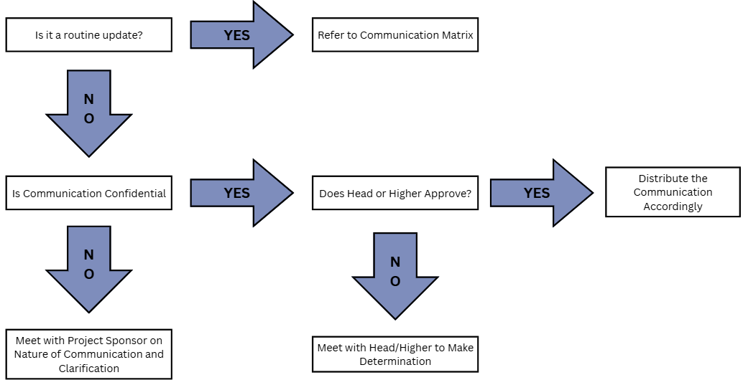

Guidelines for Meetings
All project meetings, including sprint reviews, team standups, technical design sessions, and stakeholder meetings, will be documented using Group NEXUS's standardized Minutes of the Meeting (MOTM) template. The MOTM serves as the official record for all project meetings and must be completed for every session, regardless of format or duration.

Meeting Documentation
Each MOTM record captures the following:
- Activity Details — Control number, meeting date, venue or platform, time start and end, and video recording link where applicable
- Attendees — Screenshots of the start and end of the meeting, the Meeting Facilitator, Secretary, and a complete list of attendees
- Agenda — Itemized discussion topics with corresponding key discussions, decisions made, and next steps for each item
- Action Items — A log of all tasks arising from the meeting, with the assigned person responsible and the due date for each item
Meeting Agenda
The Meeting Facilitator is responsible for preparing and distributing the meeting agenda prior to each session. The agenda must identify all discussion items to be covered and should be shared with all attendees in advance to allow adequate preparation.

Meeting Facilitation
The Meeting Facilitator is responsible for opening the meeting, guiding discussion through all agenda items, ensuring the meeting starts and ends on time, and capturing the required start and end screenshots for the MOTM record.
Secretary / Note Taker
The designated Secretary is responsible for documenting key discussions, decisions made, and next steps for each agenda item during the meeting. The Secretary is also responsible for logging all action items, including the person responsible and the due date. The completed MOTM must be finalized and distributed to all attendees within 2 business days following the meeting.
Action Items
Action items are formally recorded in the Action Items section of the MOTM. Each item must have a clearly identified owner and a defined due date. Open action items from previous meetings will be reviewed at the start of the immediately following session to confirm resolution status before proceeding to the current agenda.
Meeting Records and Archiving
All completed MOTM documents will be archived on the SharePoint platform. Control numbers must follow the NEXUS-MOTM[XX] format to ensure traceability across the project lifecycle. Video recording links, where available, must be included in the MOTM record prior to archiving.

Communication Escalation Process
Efficient and timely communication is the key to successful project completion. As such, it is imperative that any disputes, conflicts, or discrepancies regarding project communications are resolved in a way that is conducive to maintaining the project schedule, ensuring the correct communications are distributed, and preventing any ongoing difficulties. In order to ensure projects stay on schedule and issues are resolved, the team will use its standard escalation model to provide a framework for escalating communication issues. The table below defines the priority levels, decision authorities, and timeframes for resolution.

Priority | Definition | Decision Authority | Timeframe for Resolution
Priority 1 | Major impact to project or business operations. If not resolved quickly there will be a significant adverse impact to revenue and/or schedule. | DOST-STII Management | Within 4 hours
Priority 2 | Medium impact to project or business operations which may result in some adverse impact to revenue and/or schedule. | Project Sponsor | Within one business day
Priority 3 | Slight impact which may cause some minor scheduling difficulties with the project but no impact to business operations or revenue. | Project Manager | Within two business days
Priority 4 | Insignificant impact to project but there may be a better solution. | Project Manager | Work continues and any recommendations are submitted via the project change control process
** NOTE: Any communication including sensitive and/or confidential information will require approval from DOST-STII for approval prior to external distribution.

Glossary of Communication Terminology

Term | Definition
Communication | The effective sending and receiving of information. Ideally, the information received should match the information sent. It is the responsibility of the sender to ensure this takes place.
Stakeholder | Individuals or groups involved in the project or whose interests may be affected by the project’s execution or outcome.
Communications Management Plan | Portion of the overall Project Management Plan which details how project communications will be conducted, who will participate in communications, frequency of communications, and methods of communications.
Escalation | The process which details how conflicts and issues will be passed up the management chain for resolution as well as the timeframe to achieve resolution.

Sponsor Acceptance


Approved by the Project Sponsor:

Date: April 8, 2026
Marievic V. Narquita
Information Services Section (ISS) Head of DOST-STII

